1. INFORMATION GATHERING

**1.1 Project Profile: -**

|  |  |  |
| --- | --- | --- |
| Sr.no | **Title** | Detail |
| 1 | **Group No.** | 40 |
| 2 | **Project Title** | Transportation Management System |
| 3 | **Front-End Tool** | ASP.Net |
| 4 | **Back-End Tool** | Microsoft SQL Server 2014 |
| 5 | **Project Type** | Web Application |
| 6 | **Duration** | July To September |
| 7 | **Project Team Size** | Two (2) |
| 8 | **Submitted By** | Rupareliya Prinjal A.  (2023009847)  Gajera Krina B.  (2023009805) |
| 9 | **Stream** | T.Y.B.C.A.(sem-5) |
| 10 | **Guided By** | Prof. Bhavik Hirapara |
| 11 | **Submitted To** | Shree V.N. Borad Mahila BCA Collage,  Joshipura, Junagadh. |

**1.2 Introduction: -**

**Title: - Freight Bidding TMS (Transportation Management**

**System)**

To Design and implement a transportation bidding platform where logistics companies can post route-based delivery jobs and vendors can submit bids. the system will select the optimal bid based on cost, route efficiency, and efficiency, and vehicle availability.

**1.3 Scope: -**

* Route wise bid posting (generate truck request).
* Multi-criteria decision-making for bid selection.
* Role-based access (Admin, Vender, Manager).

**1.4 Objective: -**

* A transportation management system plays a critical role in managing the physical movement of goods along a supply chain and ensuring their timely delivery.

**1.5 Advantage: -**

* A TMS' intelligent routing capabilities can help users choose the most cost-effective routes and carriers.
* Real-time shipment tracking.
* Digitized Documentation and Finance Management.
* Advanced Analytics and Reporting.

**1.6 Limitation: -**

* High implementation costs.
* Potential failed implementation.
* Incorrect platform selection**.**

**1.7 Pages: -**

**User: -**

* Register Page
* Login Page
* Home Page
* About us Page
* Services Page
* Request a quote Page
* Contact us Page
* Logout Page

**Admin: -**

* Login Page
* Home Page
* Register detail
* Bid detail
* Master Page
* Logout Page

**2. REQUIREMENT ANAYLSIS**

**2.1 Tools & Technology: -**

**2.1.1 ASP.net: -**

* Asp.net is an object-oriented event driven development platform for waiting web-based application before .net active based server pages was the Microsoft technology for developing application that run through the browser.
* Because ASP.net is based on the .net framework, some classes in the framework class library are available to all .net-based application.
* Asp.net gives you the ability to code in any supported .net languages. (Including VB, C#, J# and many other languages that have their party compilers)
* ASP.net also include a file turned data access model and flexible data catching to further boost performance.
* **Advantages of ASP.net: -**
  + - * + ASP.net is integrated with .net framework.
        + ASP.net compiled .net interpreted.
        + ASP.net is multi language.
        + ASP.net is hosted by the common language runtime.
        + ASP.net is object-oriented.
        + ASP.net is multi service and multi browser.
        + ASP.net is easy to deploy and configure.
* **New feature of ASP.net: -**
* Better language support.
* Programmable control.
* Event driven programming.
* Xml based components.
* **Benefit of ASP.net are as under: -**
* Make code cleaner.
* Easy to use graphical interface.
* Provide various tools are debugging.
* Designing tools are of varied type.
* Deployment,scalability,security,reliability are improved.

**2.1.2 SQL Server 2014: -**

* SQL Server 2014 express edition is the entry level free database and is ideal for learning and building desktop and small server data drive application it is the best choice for independent software vendors, develops and hobbyists building client application.
* If you more need advanced database features SQL Server express can be seamlessly upgraded other higher and versions of SQL server.
* SQL server express LOCALB a list weight version of express that has all of its programmability features yet runs in user mode and a fast,zero configuration installation and a short list of prerequisites.
* **Feature: -**
* Resource governor
* Policy
* Table
* Back up
* Data capture
* Data collection
* **SQL Advantages: -**
* Backup encryption executed at back up time to prevent tempering.
* Tables level access control. Column level access data.
* Cross platform support and .net are.
* Transparent data encryption the ability to encryption and entire database.
* Auditing, monitoring at the data access.

**2.1.3 Java Script: -**

* Java Script is a scripting language often used to client side web development.
* Java Script was influenced by many language and was designed to have similar work to java but be easier for non-programmers to work wish
* **Features of java script: -**
* In the community of web development and surfer’s java script is highly popular as client side scripting language for the web browser.
* **Support for object: -**
* Java Script is an object-oriented language however, the way java script handles object inheritance is bit different from conventional object programming language like due to this java script support most of the object-oriented concepts while being simple to learn and use.

**2.1.4 CSS: -**

* CSS cascading style sheets.
* CSS use to control the style and layout of multiple web pages all once.
* Style are normally stored in style sheets. External style sheets are stored in CSS file.
* Style ware added to html to solve a problem.
* Multiple style definition cascaded in to one.

**2.2 User Characteristic: -**

* Basic knowledge about computer.
* User should be comfortable with English language.
* Use able to put required in formation secure user login account.
* These users are usually responsible for insuring that
* A design is feasible and software.
* More often than not software is design for a client.

#### **2.2.1 Educational Level: -**

* User should conformable with English language.
* Must have network.

#### **2.2.2 Skills: -**

* User should have basic knowledge and should be comfortable using generate purpose application on compare.
* User should have provided information on regarding the farmer.

### **2.3 Hard Ware and Software Requirement: -**

### **2.3.1 Hardware: -**

|  |  |
| --- | --- |
| Hard Disk | 500GB |
| Processor | 2.33 GHZ |
| System Type | 64 bit operating system |
| RAM | 2.00 GB |

#### **2.3.2 Software: -**

|  |  |
| --- | --- |
| Operating System | Microsoft Windows-10 |
| Development Tool | ASP.Net(visual studio 2015) |
| Technology Back End | SQL Server 2014 |

**3. Project Planning**

* We referred the book from library with the help of them we can make project more efficient & more reliable.
* Project planning is part of project management which related to the use of Schedules such as Gantt chart to plan and subsequently report progress within the project environment.
* Following this step the durations for the various tasks necessary to complete The Work are listed and grouped in to a work are breakdown structure.
* After collection all data we start make web pagesby macromedia.

**3.1 Waterfall Model:-**

* The waterfall model was first process model to be introduction it is also referred to as a liner sequential life cycle model.
* It is very simple to understand and use in a waterfall model, each phase must Be Completed be for the next phase can being and there is no overlapping in the phases.

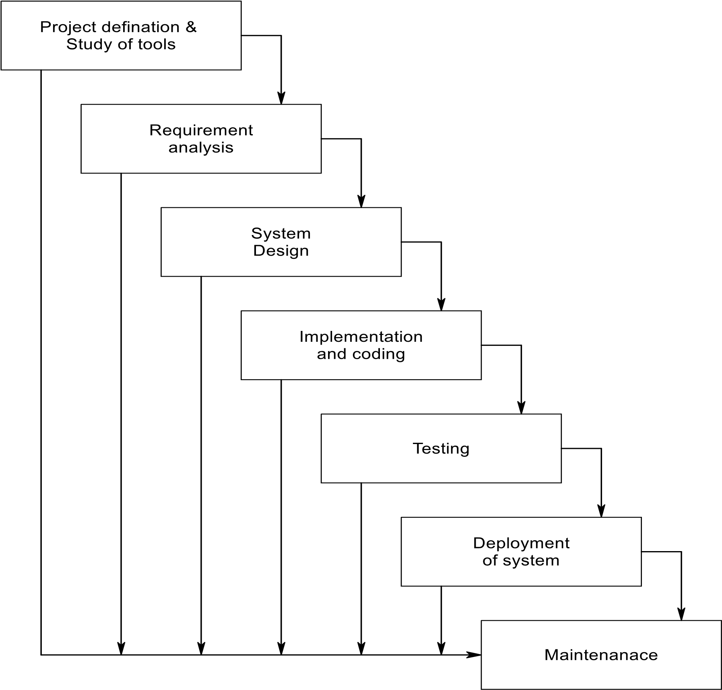

### **Project Definition & Study of Tool:-**

* To Design and implement a transportation bidding platform where logistics companies can post route-based delivery jobs and vendors can submit bids. the system will select the optimal bid based on cost, route efficiency, and efficiency, and vehicle availability.
* This system reduces manual work, saves cost and time, and brings automation into transportation management.

### **Requirement Analysis:-**

### 

* **The requirements gathering process makes stronger and focused specifically on Business activities understanding requirement, an analyst can have clear idea about the nature of the software including function behavior, performance and interface requirements for the System recorded and evacuated with the user.**

### **System Design:-**

* **Software design show following four distinct components of a program.**
* **Database design**
* **Software architecture**
* **Interface design**
* **Algorithm**
* **The process convert requirements into a symbolic representation of the software that can be used for static testing before coding like requirement the design is documented and turns out to be part of the software configuration.**

### **Implementation & Coding:-**

### 

* **The design must be converted into a machine, program the code generation Step dose this task. If design is performed in a correctly code generation can be done speedy and with more efficiency**.

### **3.1.5 Testing:-**

* **Once code developed program testing can be started. The testing process covered by static and dynamic way. It also covers structure and functional testing. For quality testing also covers non-functional requirements.**

### **Deployment of System:-**

### 

* **Once the functional and non-functional testing is done the product deployed in the customer environment or released in to the market.**

### **Maintenance:-**

### 

* **There are some issues which come up in the client environment to fix those Issues patches are released maintenance is done to deliver these changes in the customer Environment.**

## **3.2 Project Scheduling:-**

* **Project scheduling is canned with the techniques that can be employed to manage the activity that need to be undertaken during the development of a project.**



### **3.2.1 Gantt Chart:-**



# **FEASIBILITY STUDY**

* **The initial investigation points to the question whether the project is feasible a Feasibility is conducted to identity the best system that meets the all the requirements this Includes an identification description and evaluation of the proposed system and selection of the best system for the job.**
* **The requirement of the system is specified with a set of constraints. Such as system Objective and the Description of the Output. If is then duty of the analyst to evaluate the Feasibility of the proposed system to generate the above results.**

## **4.1 Technical Feasibility:-**

* **Technical analysis evaluation technical merits of the system at the same time collecting additional information about performance, reliability, maintainability and Productivity.**
* **Management agreed to purchase extra device for latest technology if necessary.**
* **The software needed to important and execute the system are already exit Technical analysis evaluation technical merits of the system at the same time collecting additional information about performance, reliability, maintainability and productivity.**

## **4.2 Operational Feasibility:-**

* **The proposed system will fulfill the company’s quarrymen.**
* **The proposed system covers all aspect of the current Manual system.**
* **The proposed system covers all aspect of the current Manual system.**
* **The human sources required number of staff operationally for the company.**
* **Proposed system is helpful for all the users associated with the organization.**
* **The decision making process of their will also become faster with the use of data Integration, consolidation so it is feasible to implement the system.**

## **4.3 Social Feasibility:-**

* **Social feasibility addresses the influences that a proposed project may have on the Social system in the project environment**
* **It should be recognized that workers in certain industries may have certain status System within the society.**
* **The ambient social structure may be such that certain categories of workers may be in Short supply or nonexistent.**

## **The stages in social assessment are:-**

* **Develop an affective public plan to involve all patenting affected public.**
* **Scoping to identify the full range of probable social impacts.**
* **Screening to determine the boundaries of the SIA.**

### **4.4 Organizational Feasibility:-**

* **I have organizational feasibility as meaning whether the new system will fit in to the Organization and meet the current goals and objectives.**
* **This involves questions such as whether the system has enough support to be implemented successfully whether it brings an excessive amount of change and whether the organization is changing two rapidly to it.**

## **Two of important factors in this are:-**

* **The passion that the sole entrepreneur or management team has for the Business idea.**
* **The extent to which the management team or sole entrepreneur Understand the markets in which the firm will participate.**

### **4.5 Economic Feasibility:-**

* **Economic feasibility is the most important and frequent used method for evaluating the effectiveness of the proposed system.**
* **It is very essential the main goal of the proposed system is to have economically Better result along with increased efficiency cost benefit analysis is usually performed for the purpose.**
* **It is the comparative study of the cost verses the benefit and savings that are expected from the proposed system, since the organization is well equipped with the.**
* **Organization is well equipped with the required hardware the project was found to be economically**.
* **Cost estimation:-**

**Working the estimation is given:-**

* **2Months and 25days=87days**
* **Hours 1 day = 87*4 = 348/24 = 15days**
* **Now, the expense & cost estimation**

|  |  |
| --- | --- |
| **Light bill** | **2000 RS.** |
| **Energy charge** | **3000 RS.** |
| **Database design** | **3000 RS.** |
| **Coding** | **5000 RS.** |
| **Internet connection** | **1500 RS.** |
| **Extra activity** | **500 RS.** |
| **Total** | **15,000 RS.** |

# **5. DATABASE DESIGN**

**5.1Use case diagram:-**

**User:-**



**Admin:-**



**5.2 DFD Diagram:-**

* **Data is the life blood of any system. Diagram of flow of data in system and its Process in which converts data into valuable information in known as data flow diagram.**
* **It will not show logic of the algorithm its shows only flow of the data from the Process to the process or from the table or from external source to the external source to the External destination**

**1) Data Process**

**2) Data Storec**

1. **External Interaction**

1. **Dynamic Connector**

#### **5.2.1 DFD:-**

**Level-0:-**

Customer

Admin

Online Examination System

**User:-**

**Level-1:-**



**Admin:-**

**Level-2:-**



### **5.3 Class Diagram:-**



### **5.4 Data Dictionary:-**

* **The Data Dictionary can be specifically defines as an exhaustively organized List of all data elements that are pertinent to the system with precise, rigorous understanding of inputs and outputs and the components of stores along with all the constraints and intermediate calculations.**
* **In other words, a data dictionary is a catalogue – a repository of element in a System. Here in a data dictionary one can find list of all the elements composing the data flowing through a system. The major elements are data flows, data stores and process. The data dictionary stores the details and description of all these elements.**

#### **Importance of Data Dictionary:-**

* **To manage the details in large system.**
* **To communicate a common meaning for all system elements.**
* **To document the features of a system. To facilitate analyst for the details in order to Evaluate system requirements**

#### **Following is the list of Tables which are used in our project.**

#### **Consider Following Data Dictionary which denotes tables detail.**

#### 

**Table:-1 Reg**

**Table:-2 Set exam**

**Table:-3 Questions**

**Table:-4 Count**

**Table:-5 Result**

**Table:-6 Contact**

### **Table:-1 Reg**

|  |  |
| --- | --- |
| **Field Name** | **Data Type** |
| **id** | **int** |
| **name** | **varchar(50)** |
| **email** | **varchar(50)** |
| **pass** | **varchar(50)** |
| **bod** | **varchar(50)** |
| **photo** | **varchar(50)** |
| **type** | **varchar(50)** |

### **Table:-2 Set exam**

|  |  |
| --- | --- |
| **Field Name** | **Data Type** |
| **id** | **int** |
| **email** | **varchar(50)** |
| **year** | **varchar(50)** |
| **sem** | **varchar(50)** |
| **subject** | **varchar(50)** |
| **time** | **int** |

### **Table:-3 Questions**

|  |  |
| --- | --- |
| **Field Name** | **Data Type** |
| **id** | **int** |
| **no** | **int** |
| **question** | **varchar(Max)** |
| **a** | **varchar(Max)** |
| **b** | **varchar(Max)** |
| **c** | **varchar(Max)** |
| **d** | **varchar(Max)** |
| **ans** | **varchar(Max)** |
| **caption** | **varchar(50)** |
| **ename** | **varchar(50)** |

### **Table:-4 Count**

|  |  |
| --- | --- |
| **Field Name** | **Data Type** |
| **id** | **int** |
| **uname** | **varchar(50)** |
| **ename** | **varchar(50)** |
| **qno** | **int** |
| **sop** | **varchar(50)** |
| **cop** | **varchar(50)** |

### **Table:-5 Result**

|  |  |
| --- | --- |
| **Field Name** | **Data Type** |
| **id** | **int** |
| **ename** | **varchar(50)** |
| **sem** | **varchar(50)** |
| **subject** | **varchar(50)** |
| **year** | **varchar(50)** |
| **uname** | **varchar(50)** |
| **email** | **varchar(50)** |
| **photo** | **varchar(50)** |
| **marks** | **int** |
| **grade** | **varchar(50)** |
| **total** | **int** |

### **Table:-6 Contact**

|  |  |
| --- | --- |
| **Field Name** | **Data Type** |
| **id** | **int** |
| **name** | **varchar(50)** |
| **email** | **varchar(50)** |
| **subject** | **varchar(50)** |
| **message** | **varchar(50)** |

**6. DATABASE NORMALIZATION**

## 

## **Normalization:-**

* **Normalization is the first step to design any database.**
* **Normalization is a database design techniques which organizes tables in a member that reduces redundancy and dependency of data.**
* **There are 3 types of Normalization.**
* **1 NF**
* **2 NF**
* **3 NF**

* **1 NF:-**
* **1Nf means First Normalization Form.**
* **There are two rules of 1NF. Remove duplicate columns.**
* **A column should contain values that are of the same type.**
* **Do not inter-mix different types of values in any column.**
* **Same names leads to confusion at the time of data retrieval.**
* **Order in which data is saved doesn’t matter.**
* **Using SQL query, you can easily fetch data in any order from a table.**

**1NF Table:-**

### **Table:-1 Reg**

|  |  |
| --- | --- |
| **Field Name** | **Data Type** |
| **id** | **int** |
| **name** | **varchar(50)** |
| **email** | **varchar(50)** |
| **pass** | **varchar(50)** |
| **bod** | **varchar(50)** |
| **photo** | **varchar(50)** |
| **type** | **varchar(50)** |

### **Table:-2 Set exam**

|  |  |
| --- | --- |
| **Field Name** | **Data Type** |
| **email** | **varchar(50)** |
| **year** | **varchar(50)** |
| **sem** | **varchar(50)** |
| **subject** | **varchar(50)** |
| **time** | **int** |

### **Table:-3 Count**

|  |  |
| --- | --- |
| **Field Name** | **Data Type** |
| **sop** | **varchar(50)** |
| **uname** | **varchar(50)** |

### **Table:-4 Questions**

|  |  |
| --- | --- |
| **Field Name** | **Data Type** |
| **question** | **varchar(Max)** |
| **a** | **varchar(Max)** |
| **b** | **varchar(Max)** |
| **c** | **varchar(Max)** |
| **d** | **varchar(Max)** |
| **ans** | **varchar(Max)** |

### **Table:-5 Result**

|  |  |
| --- | --- |
| **Field Name** | **Data Type** |
| **marks** | **int** |
| **grade** | **varchar(50)** |
| **total** | **int** |

### 

### **Table:-6 Contact**

|  |  |
| --- | --- |
| **Field Name** | **Data Type** |
| **subject** | **varchar(50)** |
| **message** | **varchar(50)** |

## **2NF:-**

## **2NF means second normal form.**

* **Create separate table for sets of values that apply to multiple records.**
* **Relate the tables with a foreign key.**
* **Records should not depend on anything other than a table’s primary key.**
* **Meet all the requirements the first normal form.**
* **Create relationship between these new tables and their predecessors through the use of foreign keys.**
* **Remove subset of data that apply to multiple rows of a tables and place them separate table.**

**2NF Table:-**

### **Table:-1 Set exam**

|  |  |  |
| --- | --- | --- |
| **Field Name** | **Constraint Name** | **Data Type** |
| **id** | **Primary key** | **int** |
| **ename** | **Primary key** | **varchar(50)** |
| **year** |  | **varchar(50)** |
| **sem** |  | **varchar(50)** |
| **subject** |  | **varchar(50)** |
| **time** |  | **int** |

### **Table:-2 Questions**

|  |  |  |
| --- | --- | --- |
| **Field Name** | **Constraint Name** | **Data Type** |
| **id** | **Primary key** | **int** |
| **no** |  | **int** |
| **question** |  | **varchar(50)** |
| **a** |  | **varchar(50** |
| **b** |  | **varchar(50** |
| **c** |  | **varchar(50** |
| **d** |  | **varchar(50** |
| **ans** |  | **varchar(50** |
| **caption** |  | **varchar(50** |
| **ename** | **Foreign key** | **varchar(50** |

## **3NF:-**

* **3NF means third normal form.**
* **All columns that are dependent on the primary key must be removed meaning that all Transitive dependency. Which occurred must be removed in separate table.**

**3NF Table:-**

### **Table:-1 Result**

|  |  |
| --- | --- |
| **Field Name** | **Data Type** |
| **id** | **int** |
| **ename** | **varchar(50)** |
| **sem** | **varchar(50)** |
| **subject** | **varchar(50)** |
| **year** | **varchar(50)** |
| **uname** | **varchar(50)** |
| **email** | **varchar(50)** |
| **photo** | **varchar(50)** |
| **marks** | **int** |
| **grade** | **varchar(50)** |
| **total** | **int** |

# **7. SCREENSHOT**

**Admin:-**

**Log in**

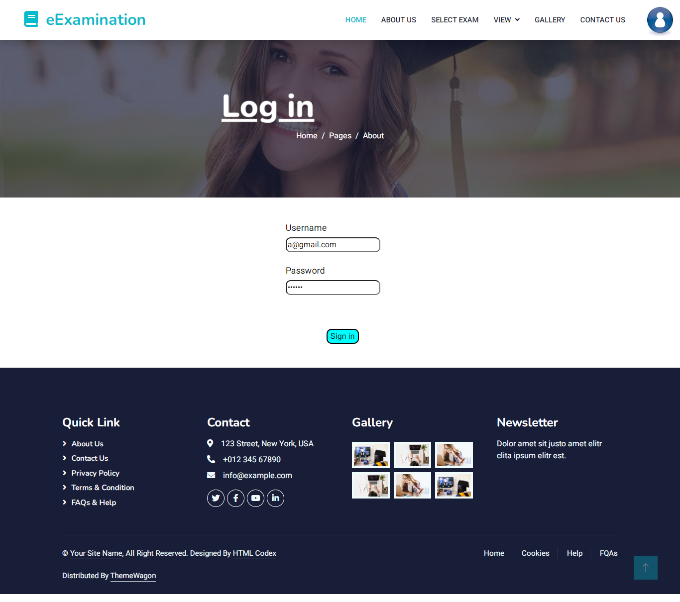

**Home**



**Set Exam**

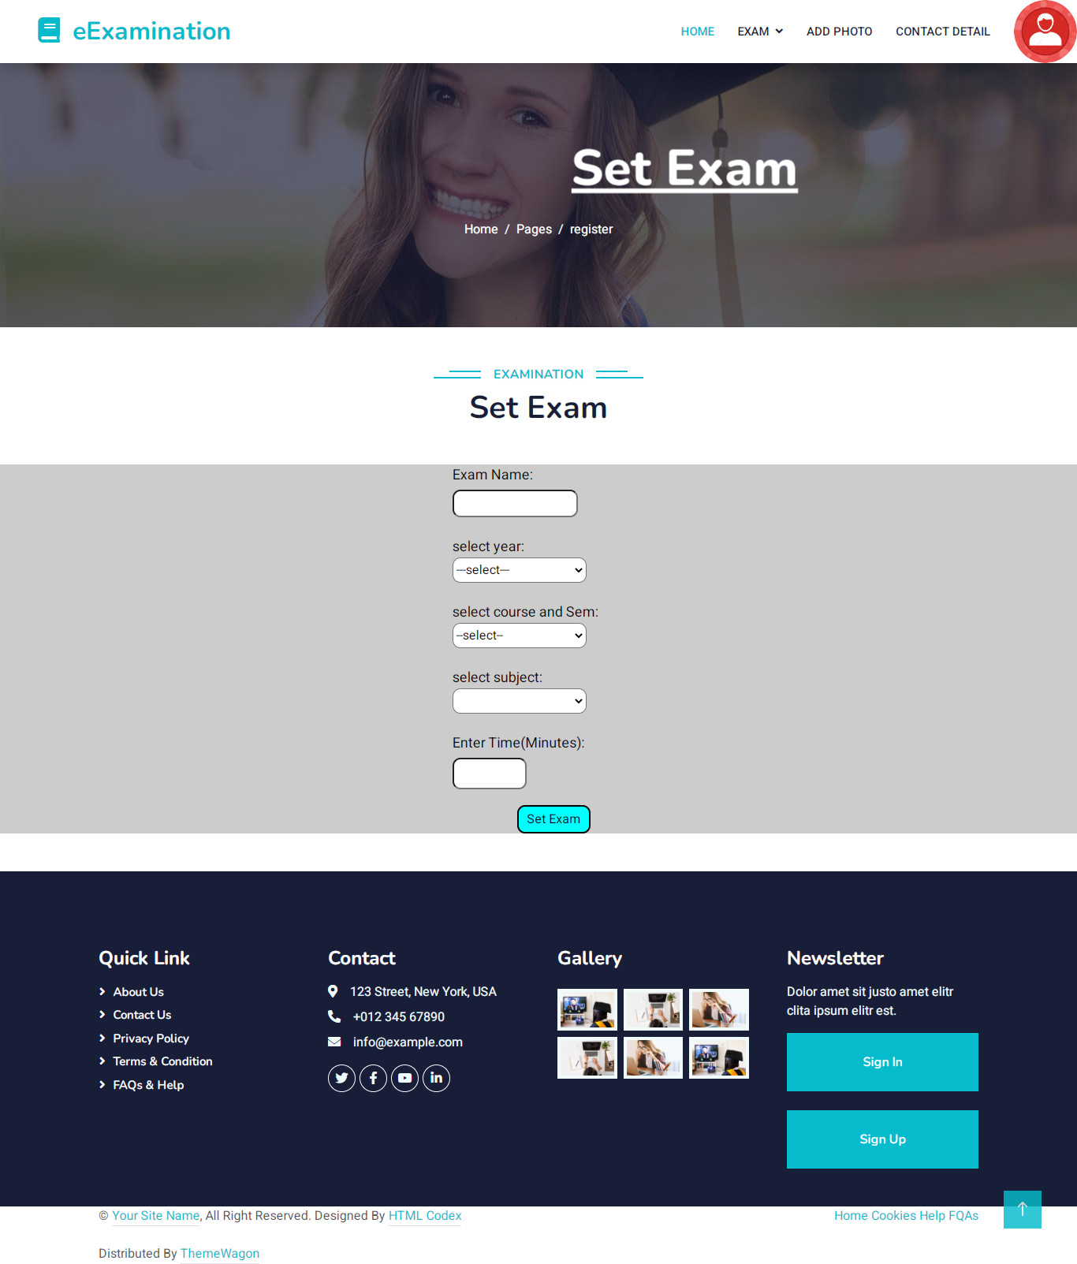

**Add Questions**

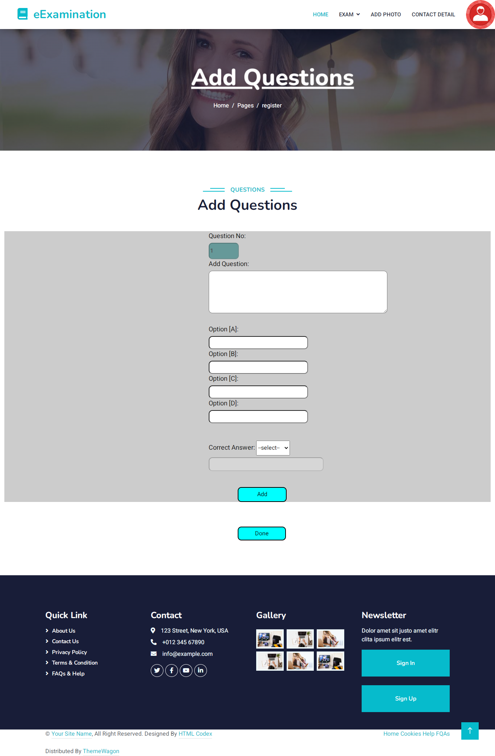

**Exam list**

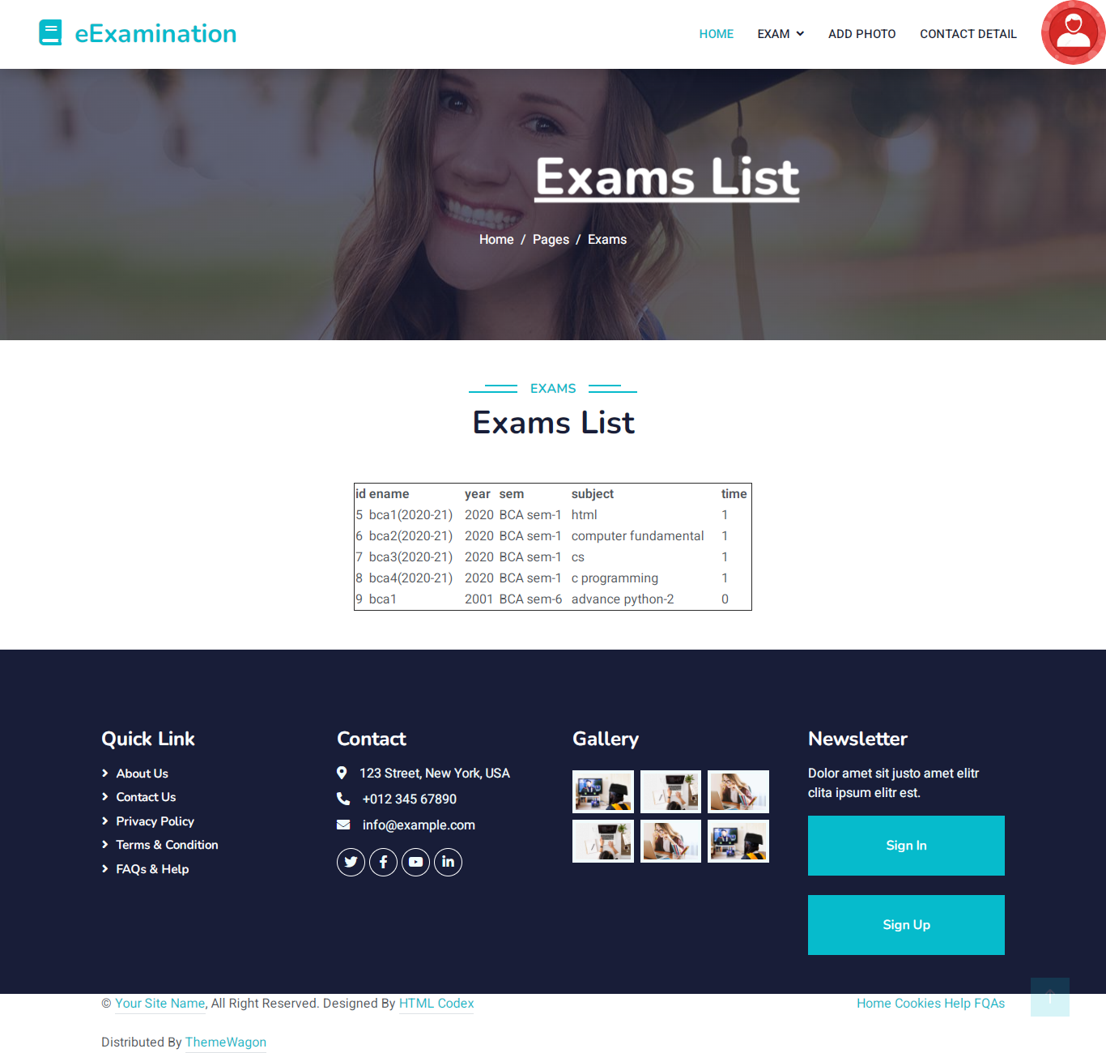

**Contact us**

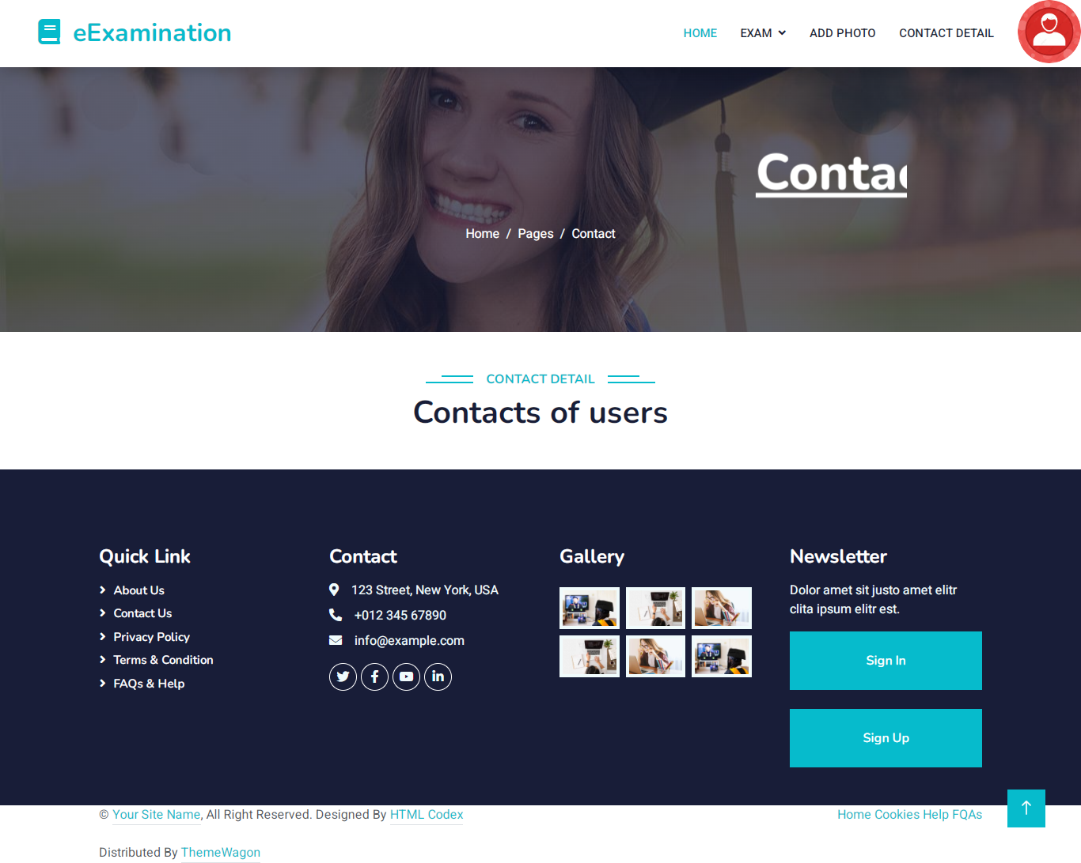

**Add Photos**

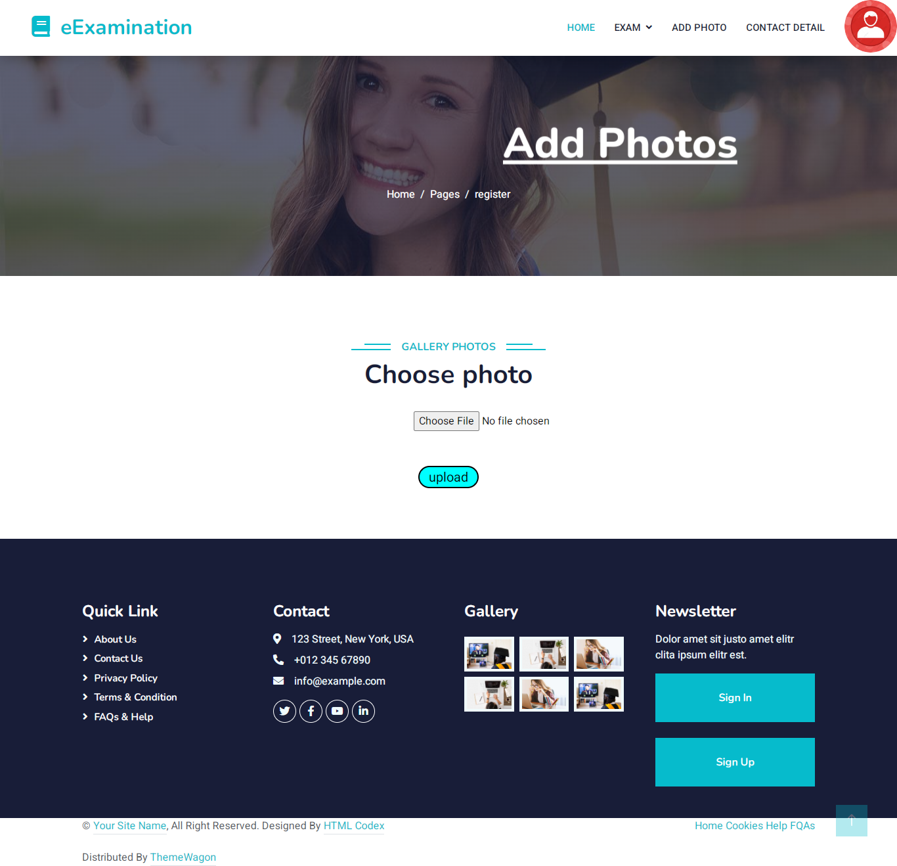

**User:-**

**Register**

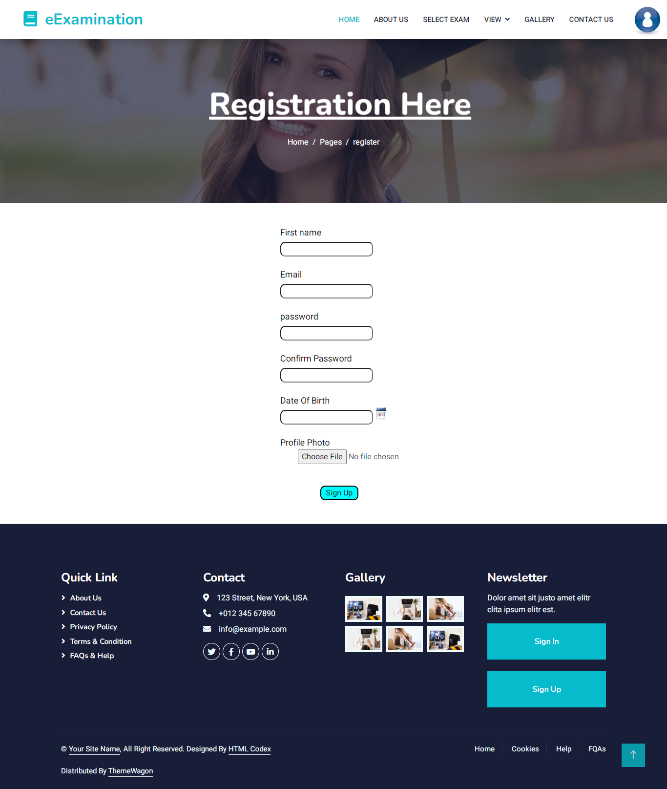

**Log in**

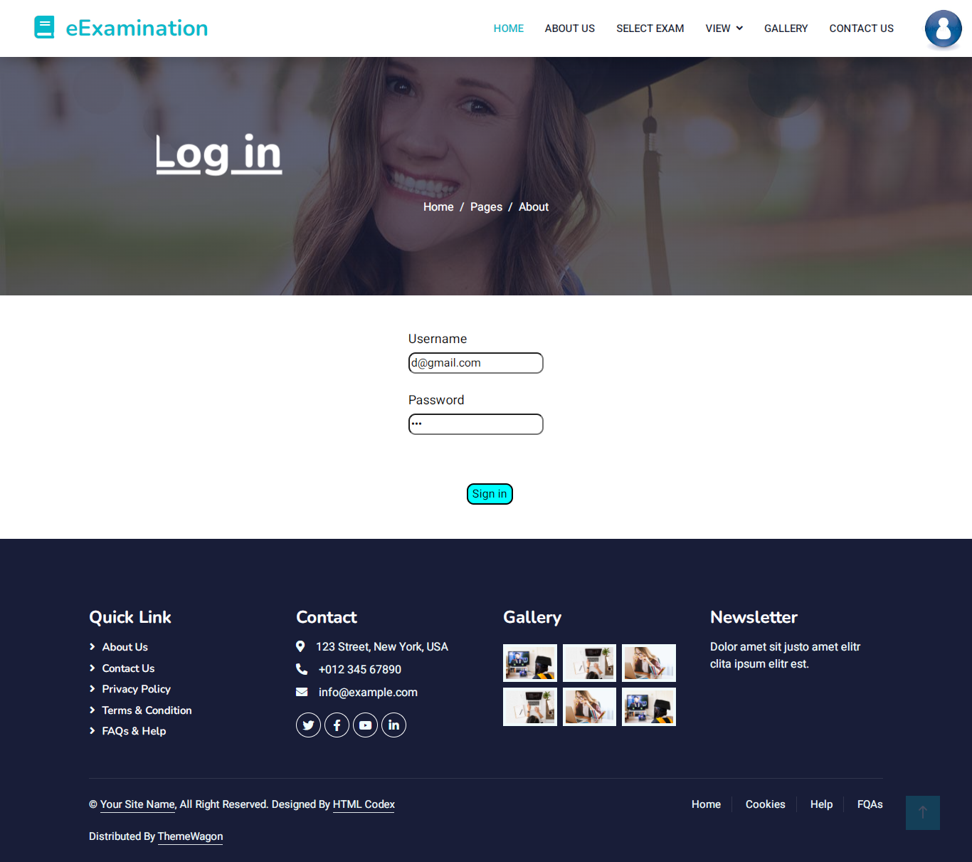

**Select Exam**

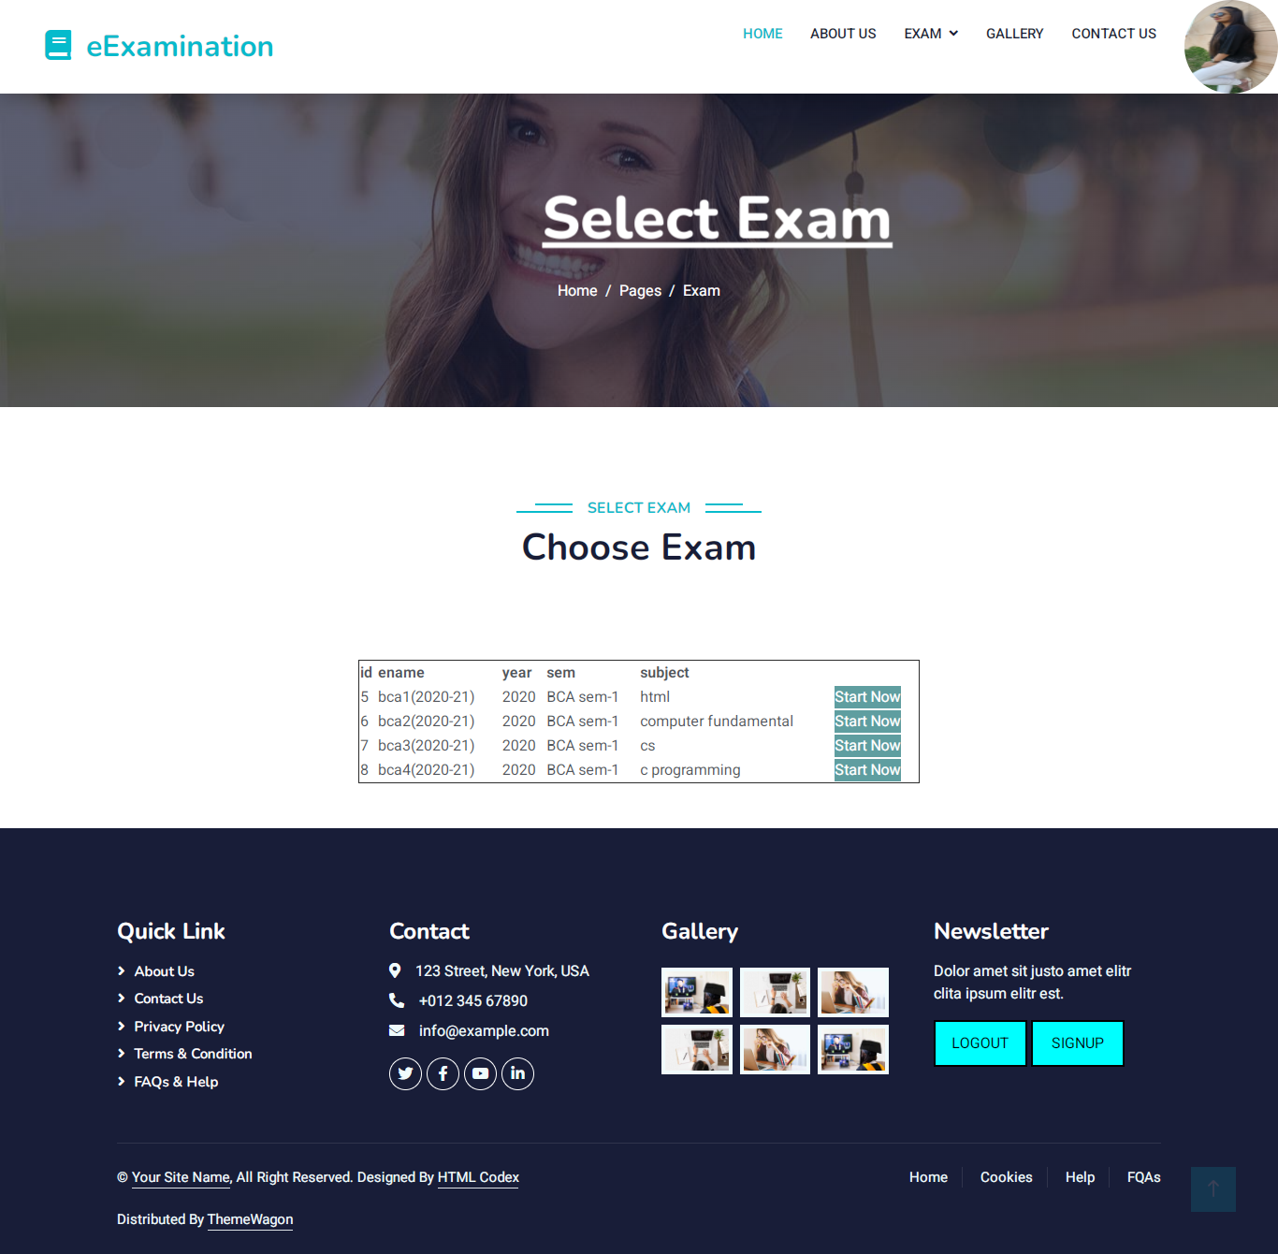

**Start Exam**

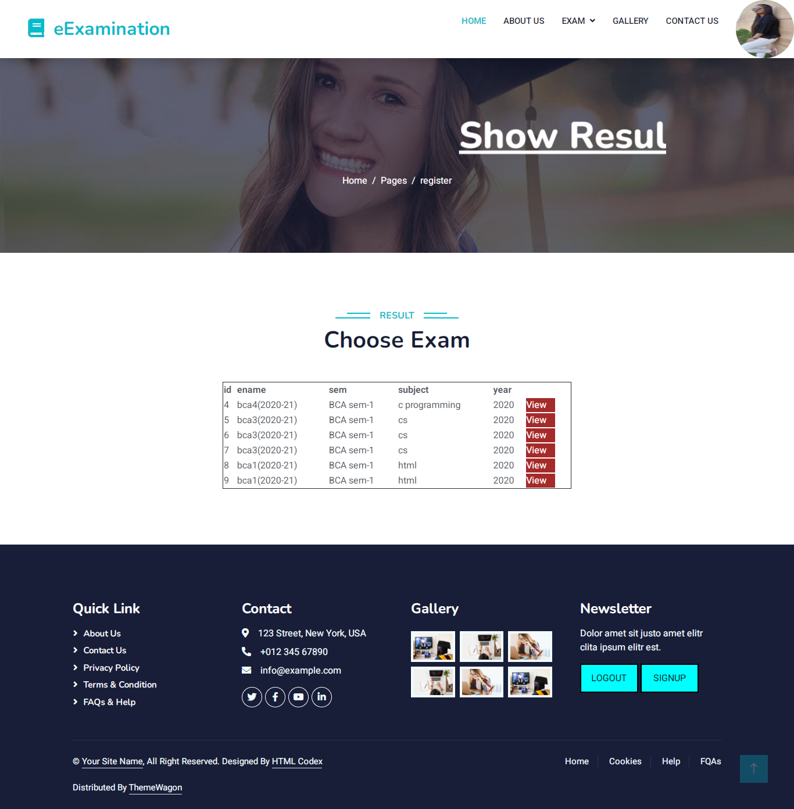

**Contact us**

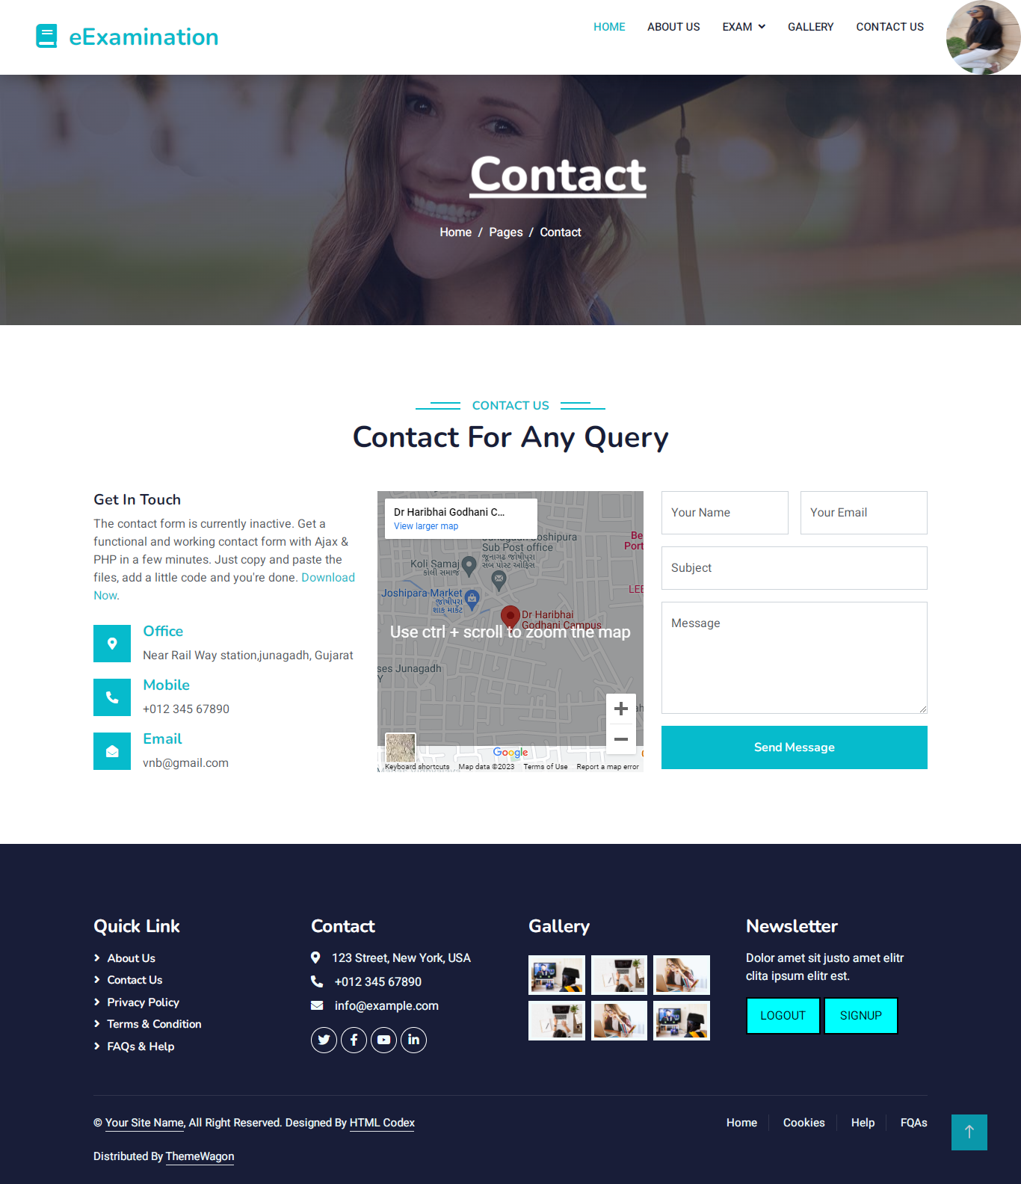

**Gallery**

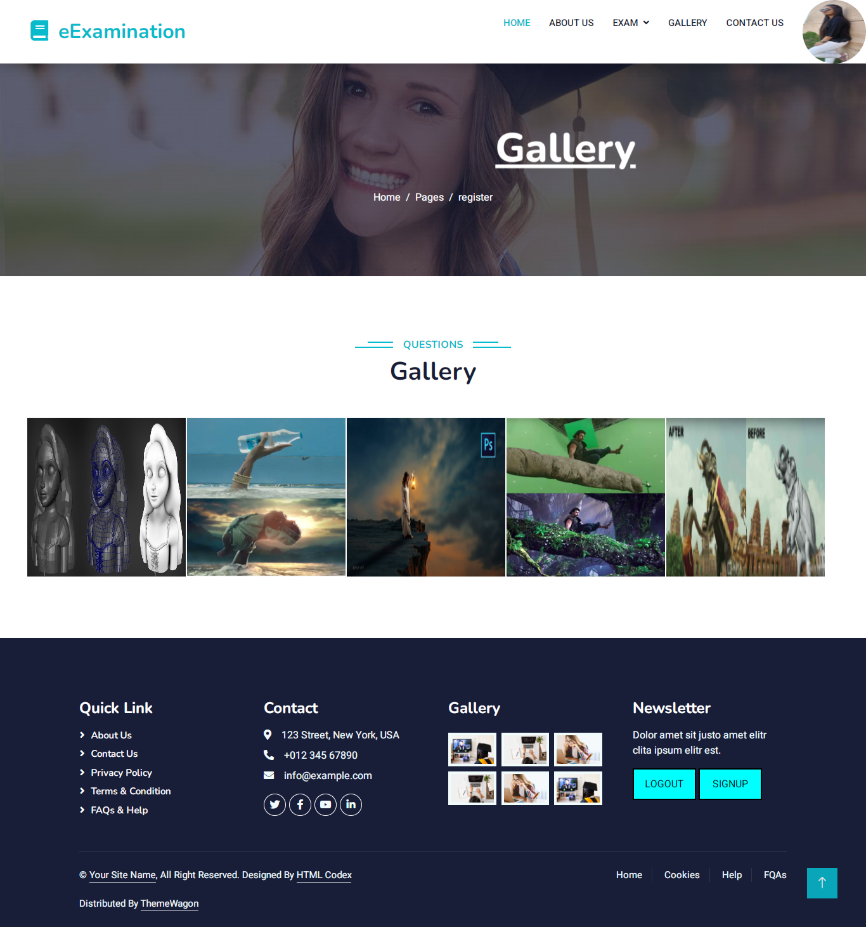

**Logout**



**Coding:-**

**using System;**

**using System.Collections.Generic;**

**using System.Linq;**

**using System.Web;**

**using System.Web.UI;**

**using System.Web.UI.WebControls;**

**using System.Data;**

**using System.Data.SqlClient;**

**using System.Configuration;**

**public partial class register1 : System.Web.UI.Page**

**{**

**SqlConnection cn;**

**protected void Page_Load(object sender, EventArgs e)**

**{**

**cn = new SqlConnection(ConfigurationManager.ConnectionStrings["cn"].ConnectionString);**

**}**

**protected void Button1_Click(object sender, EventArgs e)**

**{**

**cn.Open();**

**string qry = "select * from reg where email='" + email.Text + "'";**

**SqlCommand cmd = new SqlCommand(qry, cn);**

**SqlDataReader dr = cmd.ExecuteReader();**

**if (dr.Read())**

**{**

**Response.Write("<script>alert('this email is already exist')</script>");**

**}**

**else**

**{**

**cn.Close();**

**string str = "insert into reg(name,email,pass,dob,photo,type)values('" + fnm.Text + "','" + email.Text + "','" + pass.Text + "','" + birth.Text + "','" + FileUpload1.FileName + "','user')";**

**SqlCommand cmd1 = new SqlCommand(str, cn);**

**cn.Open();**

**int no = cmd1.ExecuteNonQuery();**

**if (no > 0)**

**{**

**Response.Write("<script>alert('you are Register successfully')</script>");**

**string photo = Server.MapPath("~//photo");**

**string st = FileUpload1.FileName;**

**FileUpload1.SaveAs(photo + "//" + st);**

**fnm.Text = " ";**

**email.Text = " ";**

**Response.Write("<script>window.location.href='..//login.aspx'</script>");**

**}**

**else**

**{**

**Response.Write("<script>alert('register not successfully')</script>");**

**}**

**}**

**cn.Close();**

**}**

**}**

**8. SOFTWARE TESTING**

* **Software testing in values the executing of a software component or system component of evaluates one or more properties of interest.**
* **Meet the requirements that guided its design the development. Responds correctly to all kinds of inputs. Perform its function wither on acceptable time. Is sufficiently usable.**

## **Type of Testing:-**

**1. White Box Testing**

**2. Black Box Testing**

**3. Validation Testing**

**4. Alpha**

**5. Beta**

**6. Manually**

### **8.1.1 White Box Testing:-**



* **As per our project, we have used white box testing model because independent Path of PHP file and loop are the cornerstones of the vast majority of all algorithms implemented in the software.**
* **White box testing sometime called glass box testing, where test data are derived from direct examination of the code to be tested.**
* **For glass box testing the test case cannot be determined until the code has actually been written both of these testing techniques have advantages and disadvantages, but when combined, they help to ensure thorough testing of the product.**

### **8.1.2 Black Box Testing:-**



* **It takes an external perspective of the test object to derive test cases. These Tests Can be functional or non-functional, though usually functional.**
* **The test designer selects valid and invalid input and determines the correct output**.
* **Interface errors.**
* **Errors data structures or external data base access.**
* **Behaviour or performance errors.**
* **Initialization and termination error.**

### **8.1.3 Validation Testing:-**

* **In validation testing, the software is assembling as a package. Validation Testing Is completely associated with requirement satisfaction of customers. According to this test, the Project is tested and found to be satisfactory for functional characteristic, behavioural characteristics and performance requirement.**

### **8.1.4 Alpha:-**

### 

* **Alpha is the first letter of the Greek alphabet. In the system of Greek numerals It Has value of 1. It was derived from the Phoenician letter alpha.**
* **Letter’s that arose from alpha include the Latin A and Cyrillic letter A. in English, The noun “Alpha” is used as a synonym for “beginning”, or “first”, Reflecting its Greek roots.**

### **8.1.5 Beta:-**

* **Beta is the second latter or the Greek alphabet. In system of Greek numerals Has Valued has of 2. In ancient Greek, beta represented the voiced bilabial plosive. In modem Greek It represents the voice labiodentals fricative. Letters that arose from beta include the roman letter (B) and Cyrillic letter (5) and (B).**

### **8.1.6 Manual:-**

* **We have done manual testing for over project all the webpages validation, Redirection, navigation are manually test by as.**

### **8.2 Test Strategy:-**

* **A test strategy is an outline that describes testing approach of the software development cycle. It is created to inform project manages testers, and developers about some key issues of the testing objective, methods of testing new functions, total time and resources required for the project, and the testing environment.**
* **Design document describe the functionality of the software to be enabled in The Upcoming release’s corresponding test strategy should be created to test the new feature sets.**

### **8.3Test case:-**

* **A test case is a set of conditions or variable under which a tester will Determine Whether a system under test satisfies requirements or works correctly. The Process of developing test case can also help find problems in the requirements or design of an application**.
* **Formal test case**
* **Informal test case**
* **Typical written test cases**
* **Error Handling**

#### **8.3.1 Formal Test Case:-**

* **The formal test case is order to fully test that all the requirements of an Application are met; there must be at least two test cases for each requirement positive test And one negative test.**

#### **If a requirement has sub- requirements, each requirement must have at least two test cases.**

* **A formal test-case is characterized by a known input and by an expected Output, Which is worked out before the test is executed.**

#### **8.3.2 Informal Test Case:-**

* **Information is valuable because it can affect behaviour, a decision, or an Outcome.**
* **For example, if a manager is told her company’s net profit decreased in the Past information as a reason to cut financial spending for the next month.**
* **A piece of information is considered valueless if, after receiving it, things Remain Unchanged. For a technical definition of information see information theory.**

#### **8.3.3 Typical Written Test Case:-**

* **A test case is usually a single step, or occasionally a sequence of steps, to test The Correct behaviour/functionally, features of an application. An expected result or expected outcome is usually given**.
* **A written test case should also contain a place for the actual result. The larger Test Case may also contain prerequisite states or steps, and descriptions.**
* **These steps can be stored in a word processor document, spreadsheet, database or other common repository.**
* **Additional information that may be included.**
* **Test case id**
* **Test case description**
* **Test case step or order or exception number**
* **Related requirement**
* **Depth**
* **Text category**
* **Author**
* **Pass/failed**

### **Error Handling:-**

### **Error:-The network path was not found**

**Solution:**-**write correct data source name**

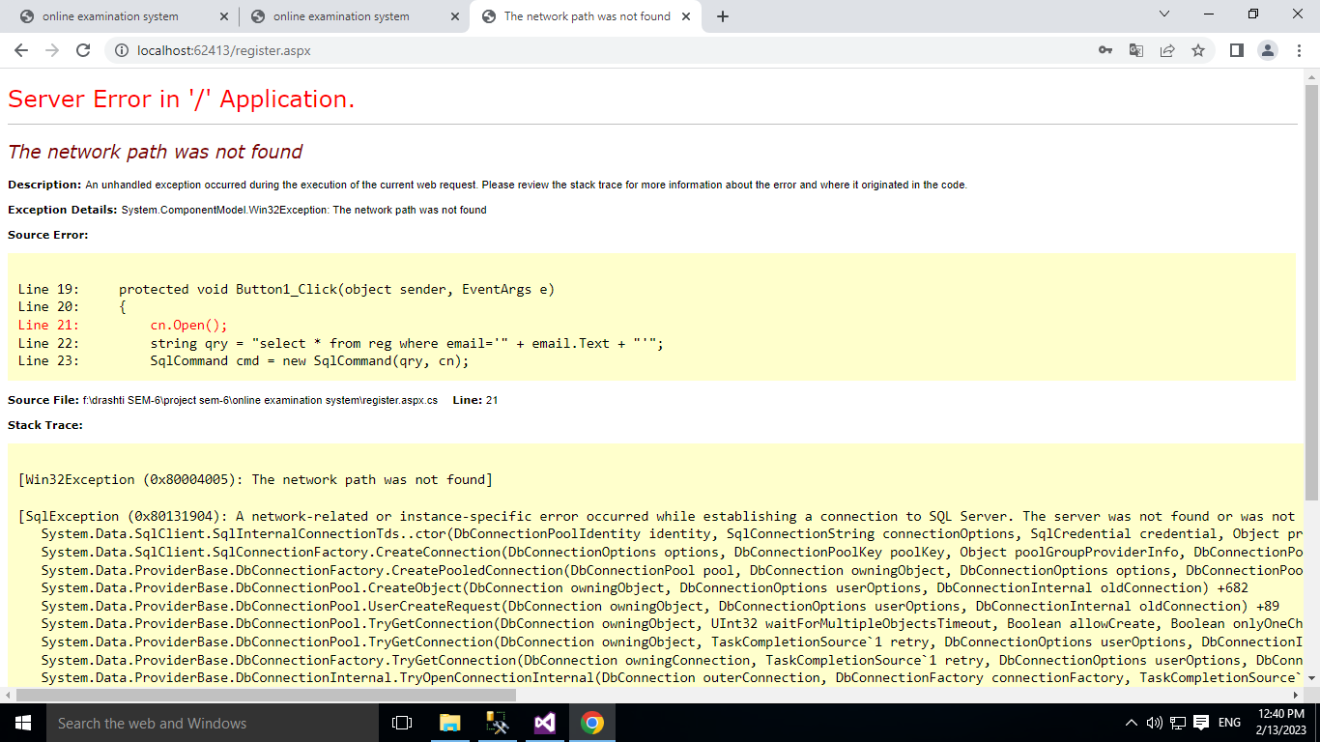

**9. PROJECT IMPLEMENTATION**

* **Implementation simply means carrying out the activities description in your Work Plan.**
* **executing a project in the water and sanitation sector is a very complex mission, as it requires the coordination of a wide range of activities the overseeing if a team, the management of budget, the communication to the public, among other issues.**
* **Project implementation is the phase where visions and plans become reality. This is the logical, conclusion, after, evaluating, deciding, visioning, planning, applying for funds and finding the financial resources of a project.**

## **9.1 User of function:-**

* **A user define function is a programmed routine that has its parameters set by The User of the user of the system.**

## **9.1.1 Admin:-**

## 

* **Admin is the heart of any application. In this project admin can view and Mange All the details about the institute.**
* **The most important facility is to manage the input validation.**
* **Another thing is that, material update, delete by the admin and add tricks so User cannot make any change in profile details. This makes the database secure and reliable.**

### **9.1.2 User:-**

* **User an individual who uses as computer. This includes expert programmer as Well as novice.**
* **An end user is any individual who runs an application program.**
* **User can login in the application with user id, password given after the Registration.**

### **9.2 Security Features:-**

### 

* **Security is an important aspect of any software components, without Reasonable Level of security, the availability, the reliability and safety may be compromised if external attack causes some damage to the system.**
* **As our application web-based so network security is an aspect which should be provided by the servers where the application is deployed.**
* **User name and password should not accessible by any other user. Only Administrator can delete users.**
* **Session is created as the user login and session is checked in all the modules.**
* **Session destroyed after the user logout to application.**

### **9.3 Coding Standards:-**

* **Tier architecture used for coding which makes the functionality easy error face, easy modification.**
* **The coding standard is the well-defined and standard style of coding with the help of the coding standard any person can go into any code and figure out what’s going on and new people can get up to speed quickly. A coding standard’s ways of doing several things such as the way variable are to be named the code is to be a id the comments are to be described, the work of function are to carried out etc.**
* **The entire query is written as a store procedure which is separately stored for further modification.**
* **Make a property file for all Queries. This will help in changing query easily without changing you. Java files. Queries can also be reused.**
* **Data source is physical storage space where they actually data stored.**
* **Connection is established in web.config file, developer doesn’t require making connection in the entire file, just have to call the connection string of web.config file.**
* **Keep few variables at class level along with frequently used DAO and Property files. Make proper usage of CSS files. Use standard Style Class defined in CSS except for exceptional cases.**
* **Write proper comments in all files for easy maintenance and understanding. Changes in the files made should also be maintained.**

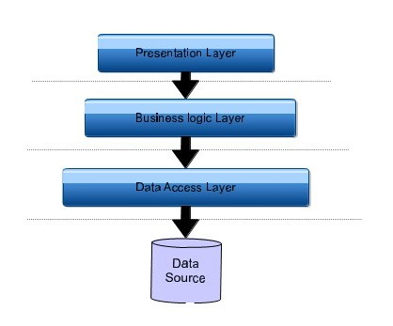

# **. LIMITATION AND FUTUR ENHANCEMENTS**

## **10.1 Limitation:-**

* **After select any option user can’t deselect that option only he/she can change that option.**
* **That exam time user can go any other place in other website.**

## **10.2 Future Enhancement:-**

* **Admin can set exam more and more**
* **Student can get his result’s message in email.**

# **11. CONCLUSION**

* **Online Examination System is useful for student and any school or college**
* **Student can give exam any place.**

# **BIBLIOGRAPHY**

**Reference book:-**

**Nirav prakashan web developing using ASP.Net**

**Website:-**

**www.w3schools.com**